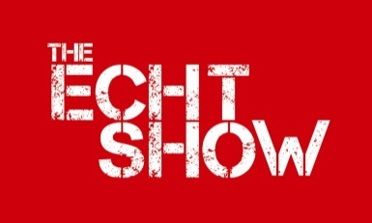
Echt, Skene & Midmar Agricultural Association
Recognised in Scotland as a Charity No SCO13971
A Company Limited by Guarantee Registered in Scotland No SC 267257

COMPANION (EXEMPTION) DOG SHOW
KENNEL CLUB RULES AND REGULATIONS APPLY
PLEASE NOTE THERE ARE 2 PARTS TO THIS FORM

ENTRY FORM FOR ALL CLASSES 14th July 2018

Please note: Only undocked dogs and legally docked dogs may be entered for exhibition at this show.

NAME OF DOG OR BITCH__________________________________________________

PEDIGREE NAME (where applicable) _______________________________________

DATE OF BIRTH________________________BREED___________________________

NAME OF OWNER___________________________________________________________

ADDRESS___________________________________________________________________

________________________________________POSTCODE _______________________

TEL _______________________________________________________

EMAIL ADDRESS___________________________________________________

CLASSES ENTERED _______________________________________________

OWNERS SIGNATURE______________________________________________

Please Note:

Your dog is vulnerable and AT RISK if left in a vehicle in high temperatures, and even on days considered as slightly warm. Please take care of your dog.
If your dog is found to be at risk, forcible entry to your vehicle may be necessary without liability for any damage caused.

Echt, Skene & Midmar Agricultural Association
Recognised in Scotland as a Charity No SCO13971
A Company Limited by Guarantee Registered in Scotland No SC 267257

General Data Protection Rules – Data Protection is changing on 25th May 2018

I agree that my details about my person (name, address, telephone number and e-mail address) may be collected and electronically stored by Echt Skene and Midmar Agricultural Association for the next 5 years. The data is stored at the secretary’s address detailed below and used for the purposes of sending you information regarding Echt Show.
Your name and area you are from (John Smith, Echt) shall appear in our schedule, catalogue, website and on occasions our social media and any newspaper articles in relation to the show.

I agree that Echt Skene & Midmar Agricultural Association for the purposes mentioned above, may contact me in the following manner (please check all applicable boxes):

by e-mail by physical mail by telephone by mobile text message

Date________ Signature_____________________________ Name____________________________

You may withdraw the consent to the use of your personal data for means of communication and you also have the right to obtain details, amend and delete your personal data at any time by contacting the Echt Skene & Midmar Agricultural Association via e-mail: secretary@echtshow.co.uk or in writing to the address below.

