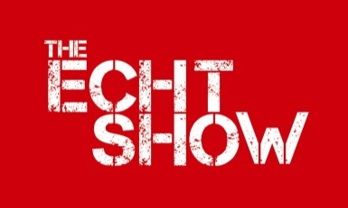
Echt, Skene & Midmar Agricultural Association
Recognised in Scotland as a Charity No SCO13971
A Company Limited by Guarantee Registered in Scotland No SC 267257

ECHT SHOW – SATURDAY 13th JULY 2019

The Secretary is required to report to BCMS, all cattle movements on and off the showfield. Please provide eartag numbers of all cattle exhibited at the show and hand this form to your steward or the abattoir on arrival. Please write clearly to avoid mistakes being made. Please note you must still report your own off and on movements to BCMS.

Exhibitor’s Name:

Holding No:

